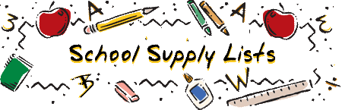

Belair Elementary School
First Grade
2025-2026
Dear Parents,
Listed below are the supplies that your child will use in first grade. Due to limited storage space, please send only those items listed below.

- 1 Bookbag
- 2 Boxes of #2 Pencils
- 2 Boxes of Crayons (24 count)
- 2 Pair of Headphones (Label with your child’s name)-NO Earbuds please.
- 2 Packs of Glue Sticks
- 1 Pencil Box
- 1 Pair Safety Scissors (rounded tips)
- 2 Folders – Pockets Only- Colors Needed: Blue & Red (Needs to be Durable)
- 2 Marble Composition Books (100 pages each)
- 2 Packs of Expo Fine Tip Dry Erase Markers (Black)
- 1 pack of 3X5 index cards

